Game Prototype Task 2

Please save all relevant files to your own folder.

Introduction
This lab builds on what you learned in the last lab, and incorporates two tanks into your game.

Objectives
After completing this lab you should have:
- Use bitmap images to construct simple animated graphics allowing 2 players to control image movement i.e. two tanks on the screen.

Google Folder Paths and gain an understanding of naming and folder structure.
Lets Begin by looking at the declarations and the form load event:

public class Form1:Form
{
string path = "E:/Tanks/";

pictureBox2.Image = Image.FromFile(path + "tank1.bmp");

The path is joined onto the image name – if the game is moved to a new folder structure then only this one statement would need to be changed.
In order to show another tank on the screen we would need to have another pictureBox control.
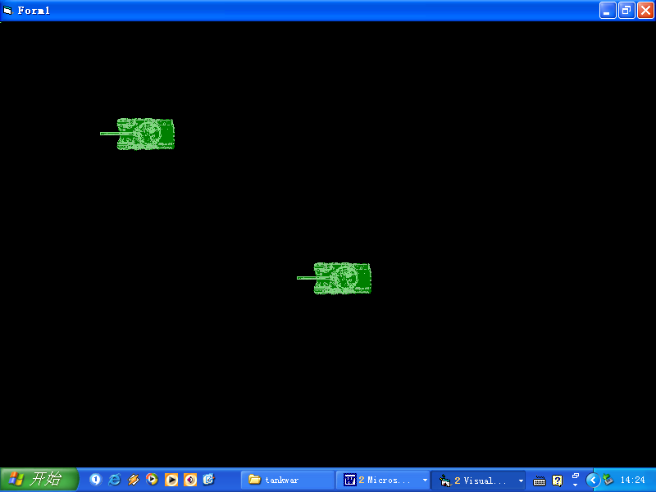
Place another pictureBox control and add the same tank image as the image file. The form should look as shown here.
Now to add movement for the second pictureBox control i.e. for the second player we use different keys. For this player we will use the Up, Down Left and Right Arrow keys. To do this we add the following code to the project.
public void OnKeyDown(object sender, KeyEventArgs e)
{

if(e.KeyCode.ToString()=="A")
{
// ….. Code from previous lab

// add onto this event the following for player 2

if(e.KeyCode.ToString()=="Left")
{
pictureBox2.Image = Image.FromFile(path + "tank1.bmp");

pictureBox2.Left = pictureBox2.Left - 5;
pictureBox2.Refresh();

}
if(e.KeyCode.ToString()=="Right")
{
pictureBox2.Image = Image.FromFile(path + "tank2.bmp");
pictureBox2.Left = pictureBox2.Left + 5;
pictureBox2.Refresh();
}

if(e.KeyCode.ToString()=="Down")
{
pictureBox2.Image = Image.FromFile(path + "tank3.bmp");
pictureBox2.Top = pictureBox2.Top + 5;
pictureBox2.Refresh();
}

if(e.KeyCode.ToString()=="Up")
{
pictureBox2.Image = Image.FromFile(path + "tank4.bmp");
pictureBox2.Top = pictureBox2.Top - 5;
pictureBox2.Refresh();
}

Therefore the form on load would look similar to that shown below:

Exercise: Get the tank to move in 8 directions

